What is Generative AI?
Generative AI is a type of AI that can create new data instead of just analyzing existing data.
👉 It learns patterns from data and then generates:
- Text
- Images
- Audio
- Video
- Code

🧠 Simple Intuition
- Traditional AI → “Classify this image”
- Generative AI → “Create a new image”

🎯 Examples
- GPT → generates text
- DALL·E → creates images from text
- MidJourney → artistic image generation

🌍 Use Cases of Generative AI
✍️ 1. Text Generation
- Chatbots
- Content writing
- Code generation

🎨 2. Image Generation
- AI art
- Product design
- Marketing creatives

🎵 3. Audio & Music
- Voice cloning
- Music composition

🎬 4. Video Generation
- AI avatars
- Automated video creation

🧬 5. Healthcare
- Drug discovery
- Medical imaging synthesis

💼 6. Business Applications
- Personalized recommendations
- Synthetic data generation

⚙️ Core Principles of Generative AI

🔹 1. Data Requirements
Generative AI needs:
- Large datasets
- High-quality, diverse data
👉 Example:
- GPT trained on massive text data
- Image models trained on millions of images

⚠️ Key Point:
Garbage in → Garbage out

🔹 2. Latent Space (Very Important Concept)
Latent space = compressed representation of data
👉 Think of it as:
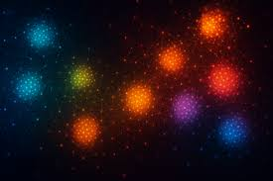
- A hidden feature space
- Where similar data points are close together

🧠 Example:
- Cat images → cluster together
- Dog images → another cluster
👉 Model learns this structure

🎯 Why important?
- Enables generation of new samples
- Allows interpolation:
  - Mix features (cat + dog → hybrid)

🔹 3. Training Phase
During training:
👉 Model learns:
- Patterns
- Distributions
- Relationships in data

Example:
- Learns grammar (for text)
- Learns shapes & textures (for images)

🔹 4. Inference Phase
After training:
👉 Model generates new data
Example:
- Input: “A cat wearing sunglasses”
- Output: New image (never seen before)

🔁 Summary
Phase | Purpose
Training | Learn patterns
Inference | Generate new data

🔥 Introduction to GANs (Generative Adversarial Networks)
One of the most important generative models.

🧠 What is GAN?
A GAN consists of two neural networks competing:
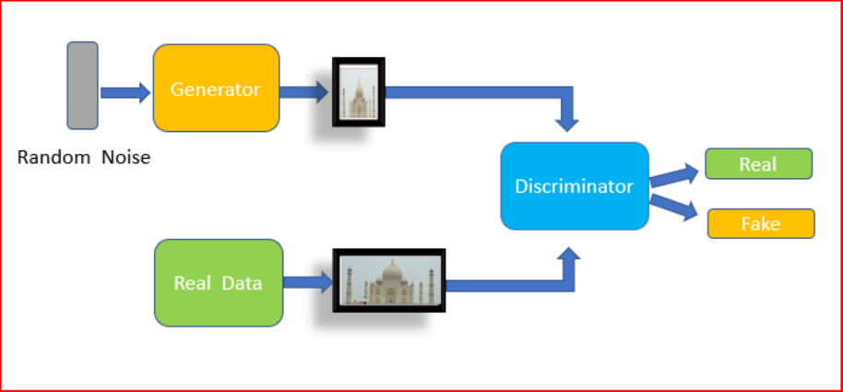

🔹 1. Generator
- Creates fake data
- Goal: fool the discriminator

🔹 2. Discriminator
- Distinguishes real vs fake
- Goal: detect fake data

⚔️ How GAN Works
- Generator creates fake data
- Discriminator evaluates it
- Feedback improves generator
- Repeat
👉 Over time:
- Generator becomes very good
- Produces realistic outputs

🧠 Intuition
Think of:
- Generator → fake artist
- Discriminator → art critic
👉 Artist improves by fooling the critic

📊 GAN Objective
- Generator: maximize mistake of discriminator
- Discriminator: minimize classification error
👉 This creates a minimax game

🖼️ GAN Workflow
Noise → Generator → Fake Data → Discriminator → Real/Fake

🚀 Advantages of GANs
- Highly realistic outputs
- Used in:
  - Image generation
  - Deepfakes
  - Super-resolution

⚠️ Challenges of GANs
- Hard to train
- Mode collapse (limited diversity)
- Sensitive to hyperparameters

🔄 Other Generative Models (Modern Context)
GANs are important, but today we also use:
- VAEs (Variational Autoencoders)
- Diffusion Models (state-of-the-art)
- Transformers (for text, like GPT)

⚖️ Generative AI vs Traditional AI
Feature | Traditional AI | Generative AI
Task | Predict | Create
Output | Labels | New data
Example | Classification | Image generation

🎯 Final Takeaway
Generative AI learns the underlying data distribution and creates new, realistic data samples using models like GANs, VAEs, and Transformers.

1. Image Generation & Enhancement
👉 Application: Ultra-realistic image creation
- Generate human faces, objects, scenes
🔹 Example:
- StyleGAN → creates realistic human faces (used in design & gaming)
👉 Where used:
- Game development
- Movie CGI
- Virtual avatars

👉 Application: Super Resolution (Low → High Quality)
GANs can convert:
- Blurry images → High-resolution images
🔹 Example:
- SRGAN (Super Resolution GAN)
👉 Real-world use:
- CCTV footage enhancement
- Satellite imaging
- Medical imaging (MRI clarity improvement)

🔴 2. Deepfakes & Face Manipulation
👉 Application:
- Replace or manipulate faces in videos
👉 Real-world use:
- Film industry (de-aging actors)
- Content creation
- Social media filters
⚠️ Also raises ethical concerns (misuse, fake videos)

🔴 3. Image-to-Image Translation
👉 Application:
Convert one type of image into another
🔹 Examples:
- Sketch → Photo
- Day → Night
- Black & White → Color
👉 Models:
- Pix2Pix
- CycleGAN

👉 Real-world use:
- Architecture visualization
- Interior design
- Autonomous driving (simulate conditions)

🔴 4. Healthcare & Medical Imaging
👉 Application:
- Generate synthetic medical data
👉 Real-world use:
- MRI/CT scan enhancement
- Tumor detection training
- Data augmentation when data is limited
💡 Important because medical data is rare & sensitive

🔴 5. Data Augmentation
👉 Application:
Generate more training data artificially
👉 Real-world use:
- Fraud detection
- Self-driving cars
- NLP datasets (limited cases)

💡 Example :
If you have:
- Few pneumonia images
GANs can:
- Generate more images → improve model performance

🔴 6. Fashion & E-commerce
👉 Application:
- Try-on systems
- Clothing generation
👉 Real-world use:
- Virtual fitting rooms
- Product visualization

🔹 Example:
- Upload your photo → GAN shows how clothes look on you

🔴 7. Gaming Industry
👉 Application:
- Generate textures, characters, environments
👉 Real-world use:
- Open-world games
- NPC character generation

🔴 8. Autonomous Driving
👉 Application:
- Simulate driving environments
👉 Real-world use:
- Training self-driving cars
🔹 Example:
- Generate:
  - Rainy roads
  - Night driving
  - Fog conditions
➡️ Helps models learn without real-world risk

🔴 9. Art & Creativity
👉 Application:
- AI-generated paintings and artwork
👉 Real-world use:
- Digital artists
- NFT generation

🔴 10. Video Prediction & Animation
👉 Application:
- Predict future frames in video
👉 Real-world use:
- Surveillance systems
- Sports analytics
- Animation creation

🔴 11. Speech & Audio Generation (less common but growing)
👉 Application:
- Voice synthesis
👉 Real-world use:
- AI voice cloning
- Music generation

🔴 12. Cybersecurity
👉 Application:
- Generate fake attacks to test systems
👉 Real-world use:
- Fraud detection systems
- Intrusion detection

1. Biggest Problem with GANs → Training Instability
GAN training is a game:
- Generator vs Discriminator
❌ Issues:
- Hard to balance both networks
- Can fail to converge
- Sensitive to hyperparameters
🔥 Result:
- Training can suddenly collapse

🔴 2. Mode Collapse (Major Limitation of GANs)
👉 What happens:
GAN generates limited variety
Example:
- You ask for 100 faces → many look similar
❌ Problem:
- Poor diversity
- Not reliable for large-scale generation

🔵 3. Diffusion Models Solve These Problems
👉 Key idea:
Instead of competition, diffusion uses:
✔ Step-by-step denoising process
✔ Learns gradually → stable learning

🔥 Why this is better:
- No adversarial training
- No generator vs discriminator conflict
- Smooth optimization

🔵 4. Better Image Quality (Important)
Diffusion models produce:
✔ More detailed textures
✔ Better lighting and structure
✔ Fewer artifacts
➡️ That’s why tools like DALL·E look more realistic than GAN outputs

🔵 5. Much Better Diversity
GAN:
- Limited outputs (mode collapse)
Diffusion:
- Generates wide variety of images
➡️ Important for:
- Creative AI
- Design tools
- Prompt-based generation

🔵 6. Works Better with Text (CRITICAL for DALL·E)
DALL·E needs to understand:
👉 “A cat wearing sunglasses on a beach at sunset”
GAN Problem:
- Hard to condition on complex text
Diffusion Advantage:
✔ Easily integrates with:
- Transformer architecture
✔ Uses text embeddings (like CLIP)

🔵 7. More Controllable Generation
Diffusion allows:
✔ Step-by-step control
✔ Prompt guidance
✔ Style control

Example:
You can control:
- Style (realistic / cartoon)
- Lighting
- Composition
GANs → much harder to control

🔴 8. Why GANs are Still Used (Important nuance)
GANs are still useful when:
✔ Fast generation needed
✔ Specific tasks (super-resolution, small datasets)
✔ Lightweight models

🔷 Final Comparison
Feature | GAN | Diffusion Model
Training | Unstable | Stable
Diversity | Low (mode collapse) | High
Image Quality | High but inconsistent | Very high & consistent
Text Conditioning | Difficult | Easy
Speed | Fast | Slow
Control | Limited | High

